OpenSCADA 0.8.0 LTS
Savochenko R. A.
OpenSCADA Team
http://oscada.org
Abstract
The report is devoted overview of the new industrial version of the project OpenSCADA for longterm support 0.8.0. Also considered interesting solutions and enhancements implemented since the new stable release.

Introduction
OpenSCADA represents open SCADA system constructed on principles of modularity, cross-platform and scalability. SCADA (Supervisory Control And Data Acquisition) is the term which it is often used in sphere of automation of technological processes. The system OpenSCADA is intended for: acquisition, archiving, visualization of the information, delivery of operating influences, and also for other related operations, which are characteristic for full-function SCADA systems.
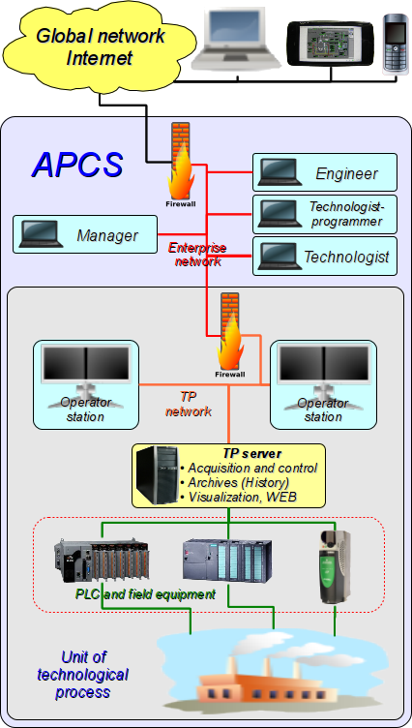
Open SCADA — “OpenSCADA” system developed since 2003 and is currently at the stage of full industrial implementation and operation by the new longterm support — 0.8.0. In parallel, work is continuing on the further development and improvement the project is largely aimed at stabilizing, new functions and areas for using, adapting execution on alternative hardware and software platforms.
The basic purposes which are pursued with the project, are:
- openness;
- reliability;
- flexibility;
- scalability;
- security;
- financial availability;
- giving of the convenient interface of management.
The system OpenSCADA is intended for performance as SCADA systems of usual functions, and for use in adjacent areas of information technologies. The system OpenSCADA can be used for next targets:
- creation APCS (SCADA) or telemechanics systems;
- building monitoring or control house automatics;
- embedded systems creation (execution environment PLC);
- dynamic models and imitators building;
- using at PC, servers and clusters: acquisition and processing information about OS, its environment and hardware;
- ERP, billing, statistic.

Solutions, built on the basis OpenSCADA
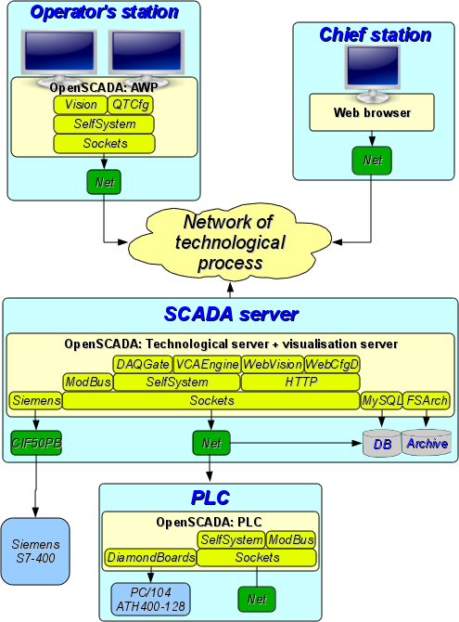
Based on the project OpenSCADA built wide range of automation solutions that clearly demonstrate the capabilities, as well as a sign of readiness of the system for wide industrial applications.
In general, OpenSCADA used by the development team to solve tasks:
- creation of two full-scale dynamic models of technological process (TP) and their control systems;
- adapting OpenSCADA on ten embedded systems;
- adapting OpenSCADA to industrial controllers: ICP_DAS LP-8781 and LP-5141;
- adapting OpenSCADA on mobile devices: Nokia N800, N900, N950, that allow build packages to run on platforms Maemo 4.1 Diablo, Maemo 5 Fremantle and MeeGoo 1.2 Harmattan, so also embrace almost the entire range Linux-smartphones and PDAs firm Nokia: N800, N810, N900, N950 and N9; which in turn allows you to create mobile consoles based on OpenSCADA for technological processes control;
- creation ten projects of realizing Human-Machinen interfaces TP.
Like to point out that there are still quote a number of solution from users OpenSCADA.

OpenSCADA 0.8.0 LTS
The release of open SCADA system version 0.8.0 is stable production release for longterm support (LTS).
The main purpose of this release is to provide for community users and developers of free software the stable platform for building solutions to complex automation systems and other adjacent solutions, and providing commercial services based on project OpenSCADA.
This release is next stable release for which provided technical support from developers and for which planned fixing releases for a long time. The life cycle of the previous stable release 0.7.0 for longterm support (LTS) ended after release version 0.8.0, by last update #8.
The key features of this version are:
- implementation of planned tasks;
- optimization, stability, robustness and performance;
- improvement and stabilization of the graphics subsystem;
- forming, expanding and stabilization of the user's programming API;
- system-wide expansion;
- publication of decisions OpenSCADA.
According to the release plan were done next tasks:
- Formation of the provision of commercial services based on OpenSCADA. — The concept is built and the mechanisms are created to provide commercial services by the developers based on OpenSCADA (http://oscada.org/en/services).
- Adaptation OpenSCADA to work on the ARM hardware platform. — The building, adaptation and full testing of OpenSCADA on the ARM architecture is made on the N800(http://wiki.oscada.org/Works/Tests/ARM (RU)) Internet tablet of the Nokia company. The build and adaptation of OpenSCADA for complex (very old) software environment of the LP-5451 controller are completed, as well as build for the SMH2Gi controller and Nokia smart phones: N900, N950, N9 are completed also.
- Implementation of the editing changes rollbacks mechanism in the Vision. — As part of the widgets' visual editing window the multi-level changes rollback mechanism is is implemented for all basic operations: visual geometry changes, the widget attribute's value change, add/remove widgets, widget's copy and edit the widgets, based on the "ElFigure" primitive.
Since the latest stable release during the work on this version, as well as during its practical adaptation, it was discovered and corrected in a total of about 300 errors.
Among the most important changes in the system OpenSCADA need note following:
- Reorganization of the source tree and build system, resulting in realized next:
  - the resources, documents and DB libraries files are moved to the separate directory and package;
  - many external functions disabling possibility is added for “poor” embedded systems;
  - modules embedding to the core library is added;
  - memory dumps automatic generation on the program crash is added.
- Working with the configure file as DB, — modifying.
- Realizing thread-safe user's objects and manipulation with objects through parameter's attributes along with basic data types.
Full current capabilities list for modules-expanding subsystems OpenSCADA:
- DB: work with DB: DBF, MySQL, SQLite, FireBird and PostgreSQL.
- Transports: external interaction by:
  - interfaces: sockets (TCP, UDP, UNIX), SSL and Serial interfaces;
  - protocols: HTTP, ModBus, OPC UA, Self and User protocols.
- Data acquisition: data exchanging with devices of the supported types and the communication methods, and also forming data by three acquisition mechanisms. Besides for data collection directly from the implemented modules of subsystem “Data acquisition” is possible to implement data sources network polling with simple communication protocols through their implementing directly on internal programming language OpenSCADA. The total list of data source modules of subsystem “Data acquisition” in version 0.8.0 LTS:
  - boards for the interface device with the object (IDO) from company «Diamond Systems»;
  - operation system (OS) data acquisition: main-boards sensors, CPU load, memory usage, access to disks, network and etc.;
  - block calculator — building of various kinds block diagrams (logical, relay, FBD, …);
  - calculator on Java-like language — all users calculation at any level of OpenSCADA system;
  - logical level of parameters — abstract layer for raw data processing and providing their in concentrate form the object of control;
  - network devices by SNMP;
  - company Siemens PLC and related;
  - PLC by protocol ModBus;
  - the interface device with the object (IDO) by protocol «DCON»;
  - equipment from company «ICP DAS»: modules series I8k and I87k;
  - data sources from OpenSCADA gate — reflection for data sources of remote OpenSCADA stations;
  - sound cards outputs;
  - data sources by protocol «OPC UA»;
  - company «Big Dutchman» automatics from automation poultry-yard by BFN concentrator.
- Data archiving(history): archiving data to file-system and DB.
- User interfaces: providing for interfaces configuring, developing and execution two types: based on library QT4 and Web-technologies.
- Special: provide special extensions:
  - users API libraries: compatible with Complex1 functions, mathematic and system functions;
  - static tests of components OpenSCADA.

New solutions and enhancements
To stable version OpenSCADA of longterm support 0.8.0 is already released two planned updates and one unplanned, in which was fixed more 50 errors of them about ten critical, as well introduced number extensions. All these fixes were made not last due to continue work on the integration to new solutions and supporting to already created.
From new solutions and enhancements I would like to note the following:
- Significant expanded the "Quick Start" guide, created video addition to it.
- Built TDE 3.5.13, continuing development for KDE3, for ALTLinux distributions, and also stabilization and fixing significant and long-standing problems.
- Built automatic systems distribution, based on ALTLinux T6, TDE 3.5.13 and OpenSCADA 0.8.0 LTS. The distribution is made in the live disc image, which you can write to optical disk and to flash(hdd)-disk and next use autonomously or to deploy the optimal and reliable automation environment based on OpenSCADA.
- Realization dispatching system for boiler #1 Public Joint-Stock Company «EVRAZ BAGLEYKOKS», Dneprodzerzinsk city. Under this system OpenSCADA has been implemented in hardware with rather low productivity:
  - PLC: Industrial PC (Advantech PCA-6753, 200MHz) with boards: A8113, DIO-144.
  - AWP: Sensor panel PC (PPC-L126T, 12", VIA Eden 667 MHz, 128 MB).
- Made new module DAQ.Comedi for work with data acquisition boards (DAQ) on buses ISA, PCI, PCMCIA and USB by library and drivers project Comedi.
- Expanded module DAQ.ICP_DAS for support large part devices company «ICP DAS» on bus ISA, for I8k and I87k series.

Conclusion
Integrated SCADA-system OpenSCADA is advanced, ready and used in harsh industrial environments to perform full range of tasks automated process control and automation in general. In addition, due to advanced user programming environment, OpenSCADA can be used in many related areas of work with real-time data, such as billing and ERP systems.
In the version of the release of industrial OpenSCADA 0.8.0 LTS done adaption for work on hardware platform ARM, in addition to already supported platforms X86 and X86_64.
The OpenSCADA developers team thankfully you for attention to the project and invites to cooperation in the various tasks of automation solve!

